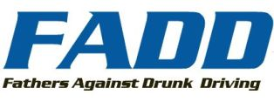

Vince Hatfield Partners with FADD
Monday, 11 October 2010
Vince Hatfield Partners with Fathers Against Drunk Driving
with His Latest New Music Weekly #1 “Through That Glass”

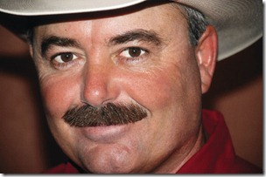
The latest number one single from Vince Hatfield, Through That Glass, is the perfect vehicle to spread the mission of Fathers Against Drunk Driving (FADD) becoming the official song for the passionate organization throughout 2011. “We are excited and honored to be teaming with Vince. What better timing could we ask for as September marks National Alcohol and Drug Addiction Recovery Month. I knew when we first heard the song that its powerful message was a perfect fit for FADD. I look forward to seeing how the partnership develops,” says FADD founder Robert Ybarra.
Through That Glass, the third consecutive number one single from an album by the same name, is an emotive and redemptive track that examines the lifelong consequences of drunk driving. This socially conscious song, written by former Texas police officer Jeff Jackson, was a therapeutic release for Jeff after he witnessed so many lives affected by driving under the influence. “I have three teenagers of my own, so when I went in to cut this track, it really hit home,” recalls Vince. “I have always wanted to find a way to share its message with an audience of people who tackle these situations daily. There’s no better place to start than with FADD. Mr. Ybarra turned a personal decision into an organization that now helps people through the US, Canada and Mexico. I tip my hat to his leadership and active strategy. I hope the song will strike a chord with his members and help everyone understand the serious consequences of driving while under the influence of any substance.”
FADD began in 1987 as the brainchild of founder Robert Ybarra. “I lost a couple of people that I loved very much: both of them were in their early 20’s at the time,” remembers Ybarra. “I decided to start picking up my friends and giving them a ride home. At the time it was called project Provide-ACampaigns Ride.” However, as more calls came in, the load was too much for Ybarra to handle alone. Consequently, he started a push for designated drivers and by 1990 FADD was firmly in place in Los Angeles. It has since developed into an organization with an extensive list of designated drivers stationed throughout the US, Canada and Mexico with additional chapter hubs in Missouri and Ohio. Their current mission is to build a facility near their home office in CA that would serve as both the education and call center hub for the organization. For more information on FADD, to view the latest research and statistics related to drunk driving, and to hear “Through That Glass” by Vince Hatfield visit, www.faddintl.org. Vince topped the New Music Weekly Country Chart with “Through that Glass” making it his fifth consecutive number one. To further give back to FADD, all proceeds on the single beginning September 1, 2010 will go directly to the organization. “I hope you’ll stop by my website VinceHatfield.com and pick up my latest single. Not only will you get the song, but you’ll also be making a donation to an organization that is helping members in your community,” says Vince. Through that Glass, produced by Grammy-nominated Eric Paul, previously charted two additional number one hits on New Music Weekly (NMW), I’m Gonna Let You Down and Shoes and Cheese. Vince, the current “NMW Breakthrough Artist of the Year,” collaborated with Country Music Hall of Famer Charlie McCoy, Grammy, ACM and CMA award-winning guitarist Brent Mason and celebrated bassist/band leader, Mike Chapman to deliver an ensemble of genuine songs about love, loss and redemption. To stay updated on Vince Hatfield, visit www.vincehatfield.com.

